东城区2015届九年级5月综合练习（一）
英语试卷
听力理解( 共 30 分)
一、 听对话,从下面各题所给的 A、B、C 三幅图片中选择与对话内容相符的图片。 每段对话你将听两遍。 ( 共 5分,每小题 1 分)
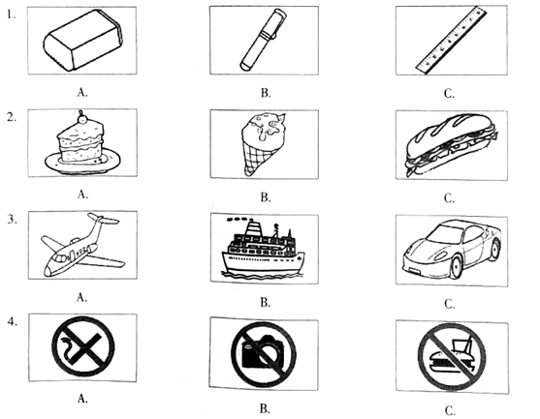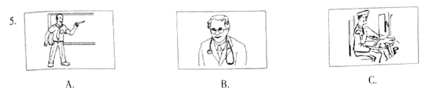
二、 听对话或独白,根据对话或独白的内容,从下面各题所给的 A、B、C 三个选项中选择最佳选项。
每段对话或独白你将听两遍。 ( 共 15分,每小题 1.5 分)
请听一段对话,完成第 6至第 7小题。
6. Whet class is James in?
A. Class 1 A. B. Class 2A. C. Class 3A.
7.Where are the speakers?
A. In the library. B.On the playground. C. At the dining hall
请听一段对话，完成第8至第9小题。
8. How long is the man going to slay in the. city?
.A. For two davs. B. For three days. C. For tour days
9. Wbat places is the man going to visit?
A. Museums. B. Buildings. C. Parks
请听一段对话，完成第10至第11小题
10. What does Stuart invite Amy to do?
A. To see a movie. B. To watch a game. C. To go to o party.
11. Why doesn't Amy went to go at first?
A. Because she wants to have a rest
B. Because she is shy to make friends
C. Because. she has to prepare for a test
请听一段对话，完成第12至第13小题。
12.What can we learn from the conversation?
A. Jane often stays up late to study
B. Jane likes talking with Chinese online.
C. Jane sometimes records programs to listen to
13.What’s the conversation mainly about?
A.Ptograms on the rodio. B.Pleasure of going online.
C.A great way to learn Chinese
请听一段独白，完成第14至第15小题。
14. Why did the speaker become really interested in running，
B. Because he was successful in running.
C. Because one of his friends encouraged him
15. what can we learn about the speaker?
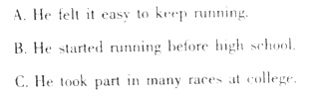
三、听独白，记录关键信息。本段独白你将听两遍。（共10分，每小题2分）
请根据所听到的对话内容和卡片上的提示词语，将所缺的关键信息填写在答题纸的相应位置上。
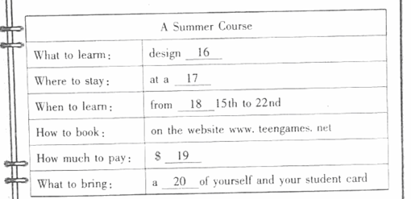
知识运用（共25分）
四、单项填空（共10分，每小题1分）
从下面各题所给的A、B、C、D四个选项中，选择可以填入空白处的最佳选项。
21.－Is this your father’s car?
－No.______car is black.
A. My B. His C. Her D. Your
22. Autumn is the best season______Beijing.
A. at B. on C. in D. to
23. Thereare only twenty minutes left, ______we’d better takea taxi.
A. so B. or C. but D. for
24. －Must I finish the work today?
－No, you ______.
A. can’t B. needn’t C. mustn’t D. shouldn’t
25. －If it______fine tomorrow, let’s have a picnic in the park.
－Great idea!
A. is B. was C. will be D. has been
26. －Jack, where is Tom?
－He______ in the library.
A. reads B. read C. was reading D. is reading
27. The woman has tried her best______a lot of poor children.
A. help B. Helping C. to help D. helped
28. －I ______this mobile phone for five years. I’m thinking about buying a new one.
A. use B. used C. have used D. will use
29. －What a beautiful picture!
－Thank you. It ______when I traveled in Paris last year.
A. takes B. took C. is taken D. was taken
30. －Do you know ______our school?
－The day after tomorrow.
A. when the American students visit[来源:学.科.网]
B. when the American students will visit
C. when do the American students visit
D. when will the American students visit
五、完形填空（共15分，每小题1.5分）
阅读下面的短文，掌握其大意，然后从短文后各题所给的A、B、C、D四个选项中选择最佳选项。
An Imperfect Painting
My parents always wanted me to be “on top”,so from early on I had the 31 to be the best in everything,from getting the highest score in a spelling test to running fastest in a race.
In middle school，I realized how many other smarter and faster people there were, It became 32 that I was not the best any more, but my parents still held on to theirhope and forced me to try hard.To their disappointment, I became less confident and didn’t want to work harder because,to me, there was no point in making any more 33 if I was unable to be number one. My grades began to fall; I never practiced the piano; I 34 painting.It was all because motivation(动力）to do anything had dropped much.
When high school started, I was at a newschool in a newcity. I 35 to get back my motivation and start over.So I picked up my ever favorite hobby again and enrolled(报名)myself in the art course,36 ,our art teacher, Mr.Grady, gave us more freedom with our art projects. He would always encourage us to realize our potential(潜力).
My first painting was simply a bee sitting on a sunflower, I tried my best, but still found it hard to feel satisfied with it. I knew it was not 37 and could hardly get a good grade. But I showed it to Mr.Grady. He didn’t 38 it in a rush. Instead, he gave me advice which only motivated me to work harder on it. For the first time I was happy with the 39 of my painting rather than disappointed about its imperfection. I finished all the other projects with higher grades, but I hung the first painting in my room at the end of the term.
My parents thought 40 me to be number one would motivate me. Instead, it discouraged me much when I was not number one, for I had gone to school only to get a grade, not knowledge, let alone progress. Actually, it is okay not to be the best at everything as long as you continue to try your best.
31 A. ability B. chance C.goal D. way
32 A. strange B. obvious C. acceptable D. impossible
33 A. efforts B. choices C. promises D. wishes
34 A. regretted B. considered C. continued D. stopped
35 A. failed B. refused C. decided D. waited
36 A. Naturally B. Similarly C. Normally D. Luckily
37 A. famous B. modern C. perfect D. special
38 A. name B. grade C. hang D. finish
39 A. progress B. meaning C. style D. title
40 A. instructing B. helping C. encouraging D. pushing
阅读理解（共50分）
六、阅读下列短文，根据短文内容，从短文后各题所给的A、B、C、D四个选项中，选择最佳选项。（共30分，每小题2分）
A
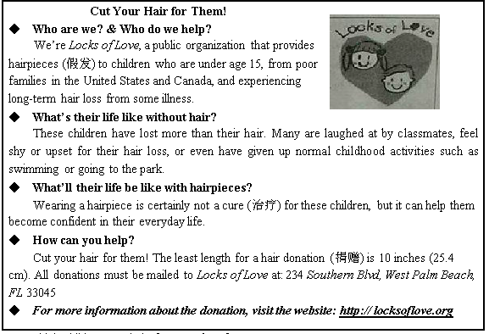
41.Which child can get help from Locks of Love?
A. A 14-year-old child in England. B. A 16-year-old child in Canada.
C. A 9-year-old child in the U.S. D. A 6-year-old children in France.
42.Locks of Lovecan help the children ________.
A. become confident B. go back to school[来源:学科网ZXXK]
C. become clever D. grow new hair
43. How can we help the children?
A. Write letters to them. B. Cut out hair for them.
C. Do activities with them. D. Help them with their study.
B
A Growing Plan
Drew, Emilio, and Michisat at a picnic table in the City Park in Oklahoma. They didn’t care about the sounds around them. They just focused on the task they had planned to complete.
They wanted to start a school garden at Jefferson Middle School. At first, it was Dew’s idea. Hefirst saw a school garden when he visited his cousin P. J. in Washington. He was surprised at the variety of fruits and vegetables the students at P. J.’ s school grew.
When Drew returned from his trip, he told his friends all about what he had seen. Now the three of them decided to make a plan to make Ms. Milano, the school headmaster (校长), believe that the garden was a good idea.
“We are going to need a teacher to guide us through the project, ” said Drew. “ I know that Mr. Hasselbach gardensat home. Just last week he brought in a whole basket of tomatoes from his garden. He might be happy to help.” Drew wrote down Mr. Hasselbach’s name in his notebook.
“We might need some money to get the project up and running,” added Michi. “We could tell Ms. Milano that we will organize a book sale to raise money.”
“That’s a great idea,” said Emilio. “ My aunt is a co-owner of a nursery (苗圃). She can help us design the garden, select plants, and create a budget (预算).”
Drew nodded and made some more notes. “If we havea garden, think of all the lessons
we’ve learnt. We’ll have to measure and weigh things. We can practice what we learn in the science lessons. There is no way that Ms. Milano could refuse us!”
Michi and Emilio smiled. “If everything goes as planned, we’llbe digging in the dirt very soon!”[来源:学科网ZXXK]
44. Where would the garden be built?
A. In a park in Washington. B. At Jefferson Middle School
C. In a park in Oklahoma. D. At P. J.’s school.
45.How would the three students get money for the project?
A. By organizing a book sale.
B. By working in a science lab.
C. By selling tomatoes to teachers.
D. By asking their relatives for help.
46. Who would help design the garden?
A. Ms. Milano. B. Mr. Hasselbach.C.Emilio’s aunt.D. Drew’s cousin.
47. What do we know about the three students from the passage?[来源:学科网]
A. They were afraid of the headmaster.
B. They were bored with science lessons.
C. They were good at the work in the garden.
D. They were confident about their plan at last.
C
Alexis Martin is a three-year-old girl from Arizona. She hasn’t started kindergarten(幼儿园)yet, but she has an IQ above 160, which is well above the average (一般的)people’s IQ. So, there is no wonder that she has become the youngest member of Mensa, the largest and oldest high IQ society in the world. Mensa is an international club whose members must have an IQ score in the top 2% of the world. Currently, Mensa has 3,300 members under the age of 18 in the U.S. Alexis is one of them.
The average people generally have an IQ score of 100 points, but Alexis scored 160 points, the highest score on the test. The doctors who tested Alexis said she scored so high that they couldn’t even work out her IQ exactly. They think she is even smarter than 99.9% ofthe world population. Actually, she matched the IQs of talents like Albert Einstein, Stephen Hawking and Bill Gates.
I an Martin, Alexis’ father, said his daughter showed signs of some special abilities at the age of one and she began reading books for pupils when she was just two years old. Now at the age of three, Alexis is reading on a fifth gradelevel.
“From 12 months old, we’d be driving around in the car and she would repeat her bedtimestories from the night before,”he said. “She didn’t just repeat them. She could remember every word of them exactly.”
Ian Martin thinks his daughter also stands out when it comes to learning new languages. “Anytime she learns a word and just picks it up through anything. She never ever uses it in the incorrect situation, ever.”Ian said.
While Alexis’s parents are proud that their three-year-old daughter has become a member in Mensa, they are also aware of the price that comes with every gift. The doctors say Alexis should never attend a normal school and children with her level of intelligence(智力)[来源:Zxxk.Com]
often experience high anxiety(焦虑) unless they’re around similarly gifted boys and girls. Her parents decide to follow the advice and try to look for proper ways to help her get involved into society.
48. Mensa only accepts ____________.
A. teenagers under 18 in the U.S.
B. people with IQs above 160 in the U.S.
C. talents in the world like Albert Einstein
D. people withIQs in the top 2% of the world
49. From the passage, we know that Alexis’ IQ is____________.
A. getting higher through training
B. beyond the limit of the IQ test
C. above the IQ of Stephen Hawking
D. growing too fast to get an exact score
50. One of Alexis’ special abilities is that____________.
A. she could read stories at the age of one
B. she could write books for pupils at the age of two
C. she canremember every word of what her parents said
D. she can learn new words quickly and use them properly
51. What can we learn from the last paragraph?
A. Alexis is sure to experience anxiety in the future.
B. Alexis’parents can’t afford the gift that she chooses.
C. Alexis’parents won’t be able to find her a normal school.
D. Alexis may feel it hard to get along with the average people.
D
It is an argument that has divided the East and the West for centuries: Are chopsticks better than the knife and fork, or vice versa? Now the winner may finally be decided, on environmental ground.
Chopsticks are made from a variety of materials, but bamboo and wood chopsticks are more popular. They are usually cheaper, lower in temperature conduction and provide better sense for holding food. That’s why almost all disposable (一次性的) chopsticks are made of bamboo or wood. With cutting down 25 million fully-grown trees a year to make chopsticks, China has ranked number one among the producers. “We must change our habitsand encourage people to take their own chopsticks when eating out,” said Mr. Bo, the owner of a forestry industry company in China. He even wentso faras to suggest that restaurants should offer metal knives and forks instead. If Mr. Bo’s suggestion is widely accepted, it would be a dark moment in chopsticks’ 4,000-year history.
Chopsticks were invented in ancient China and later spread around Asia. They are not only used as eating tools but also used for cooking, stirring the fire and serving food. Koreans sometimes use metal chopsticks because of their love of barbecue (烧烤). Chinese chopsticks are longer than Korean and Japanese chopsticks in order to reach the dishes in the center of the table. There are 1.4 billion people using 80 billion pairs of disposable chopsticks in China every year. However, the most widespread use of disposable chopsticks is in Japan. Around a total of 24 billion pairs are used in Japan each year, which means each Japanese uses almost
200 pairs yearly. However, most of its disposable chopsticks have been imported (进口) from China, up to over90%.
Today, China has to accept the truth that its forests can no longer provide enough chopsticks to feed Asian’s table habit. China is now the world’s largest importer of wood and even imports chopsticks from America. An American company said that the state’s native sweet gum and poplar wood would be perfectly used to make chopsticks. These materials do not need to be lightened with chemicals or bleach (漂白粉). The healthy materials and fairly reasonable prices of the products are appealingto Asian customers. More and more Asians start to use American-made chopsticks at their tables.
Although the U.S. has a huge amount of wood, which reduces the number of trees that are cut down in Asia, changing the table habit of using disposable chopsticks still seems to be a wiser choice for chopsticks-using countries.
52. According to Paragraph 2, Mr. Bo’s advice is that Chinese should ____________.
A. use metal chopsticks instead of wooden ones
B. plant more trees and produce fewer chopsticks
C. form the habit of taking their own chopsticks when eating out
D. change their habits and begin to use knives and forks at home
53. What do we know about chopsticks in Asia?
A. Koreans mainly use chopsticks to cook food over a fire.
B. Most disposable chopsticks in Japan are made in China.
C. The most disposable chopsticks are used in Japan yearly.
D. Chinese use the shortest chopsticks to take and serve food.
54. The underlined word “appealing” in Paragraph 4 probably means ______
A. normal B. necessary C. attractive D. surprising
55. What’s the best title for the passage?
A. Time to Change the Materials for Chopsticks
B. Time to Cut Down on Disposable Chopsticks
C. Time to Import Disposable Chopsticks
D. Time to Give UpUsing Chopsticks
七．阅读短文，根据短文内容，从短文后的五个选项中选出能填入空白处的最佳选项。每个选项只能用一次（共10分。每小题2分）
Doctors in Germany have warned people that headbanging could be bad for your health. __________ (56). Dancers shake their heads back to front, and from side to side, very quickly.
Doctors say this would injure(伤害) the brain. __________ (57). The man had no history of head injuries but had been headbanging for many years.He began to have bad headaches after going to a heavy metal concert. __________ (58) They gave him a brain scan(扫描) and found bleeding in his brain. He needed an operation to repair it. Doctors made a hole in his brain to take out some blood. __________ (59)
Doctors said the risk of injury to the brain from headbanging is low and heavy metal fans do not need to stop doing the dance completely. The head doctor, Ariyan Pirayesh, said: "We are not against headbanging. Rock 'n' roll will never die. __________ (60). We just think if our patient had gone to a classical (古典的) concert,this would not have happened."
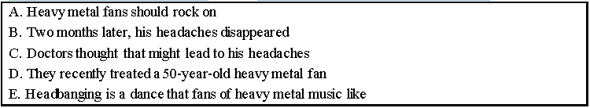
八、阅读短文，根据短文内容回答问题。（共10分，每小题2分）
了 I love travelling so you can imagine my disappointment when I know that my local train station would be closed for five months. Unfortunately I do not have a car but I realized that I could start carpooling.
Carpooling is the sharing of car journeys so that more than one person travels in a car. As a result, carpooling can be a cheaper choice than public transport because everyone in the car shares the cost of petrol (汽油). I recently did carpooling for the first time and it was very easy to find a driver. I used a website which lists drivers’ descriptions and found someone who was going to the same place as me. The descriptions provided a lot of information such as the driver’s first name, age and gender as well as reviews form previous (以前的)passengers. I decided to travel with a lady who had very good reviews. I paid for my share of the petrol through the website and planned to meet her in the town center.
It may seem quite dangerous to travel with strangers but there are some safety actions. Firstly, the driver cannot receive your money until you text him or her a code (密码) at the end of your journey. This means that if you are unsatisfied with your trip, the driver will not be paid. Secondly, it is important to read quite a number of the drivers’ descriptions and reviews when you choose a driver. Lastly, I would suggest travelling with a friend so that you will feel safer and less lonely.
I had a very good experience of carpooling. Not only was the trip very cheap, but the driver and the other passengers were really friendly. They were all French so I had the chance to practice speaking some French. As train and petrol prices are rising, both drivers and passengers can benefit from this cheaper form of travel. More importantly,, carpooling provides a fantastic opportunity to meet interesting people on your travels.
61. How did the writer usually travel before starting carpooling?

62. Who pays for the petrol when people do carpooling?

63. When can the driver receive the money from a passenger?

64. To keep safe, what does a passenger need to do when choosing a driver?

65. In the writer’s opinion, what are the advantages of carpooling?

书面表达（15分）
根据中文和英文提示，写一封意思连贯、符合逻辑、不少于50词的回信。信的开头和结尾已给出，其词数不计入所完成的回信内。所给英语提示词语仅供选用。请不要写出你的校名和姓名。
66.假如你叫Lily，你的一位美国网友Helen在她的博客里提到最近她和她的好朋友之间产生了矛盾。她不知道自己是否做错了什么？她该怎么做才能与这位朋友重归于好？请你给她一些建议，并谈谈你对于“好朋友”的理解。
