北京市西城区2015年初三一模试题
英语
听力理解( 共 30 分)

一、 听对话,从下面各题所给的 A、B、C 三幅图片中选择与对话内容相符的图片。 每段对话你将听
两遍。 ( 共 5分,每小题 1 分)
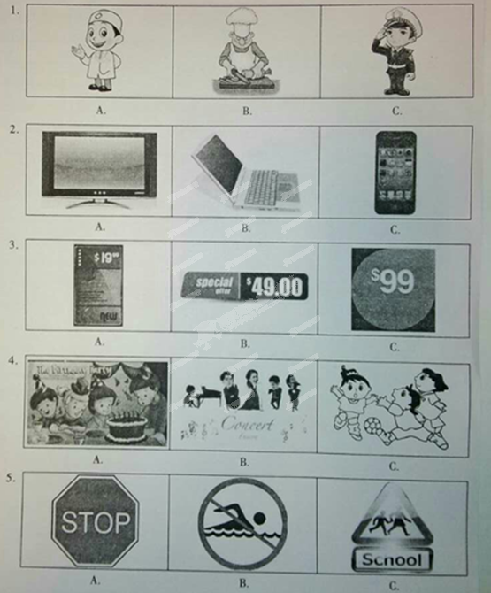

二、 听对话或独白,根据对话或独白的内容,从下面各题所给的 A、B、C 三个选项中选择最佳选项。
每段对话或独白你将听两遍。 ( 共 15分,每小题 1.5 分)
请听一段对话,完成第 6至第 7小题。
6、What’s the matter with the man?
A.He’s got a cold B.He’s lost hix umbrella C.He’s had an accident
7.What was the weather like yesterday afternoon?
A.Sunny B.Windy C.Rainy
请听一段对话,完成第 8至第 9小题。
8.What’s Helen going to do on Friday evening?
A.To visit her neighbours
B.To go out with her friends
C.To have a birthday party
9.What’s the woman going to take with her?
A.A bottle of wine B.Some food and drinks C.Some flowers
请听一段对话,完成第 10至第 11小题。
10.What can we learn about the man?
A.He learnt cooking from his mother
B.He is taking a cooking lesson
C.He works in a restaurant
11.What makes the woman get bored now?
A.Cooking at home
B.Eating take-out food
C.Being busy with her work
请听一段对话,完成第 12至第 13小题。
12.What is the woman doing now?
A.Putting paper cuts on the window
B.Teaching how to make paper cuts
C.Drawing some pictures for paper cuts
13.How did the woman get her paper cut?
A.She bought it at a local market
B.She got it from an old lady
C.She made it all by herself
请听一段对话,完成第 14至第 15小题。
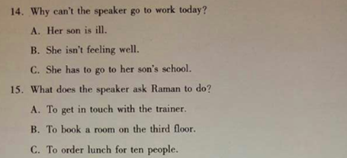
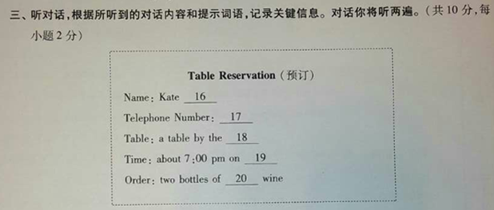
四、单选
21.Where is Mike? Have you seen_______?
A. he B. him C. his D. himself
2.Lily _______ many English novels since she went to the Middle school.
A.read B.reads C.has read D.is reading
3.Betty is_______ than any other girl in her class.
A.as tall B.taller C.tall D.the tallest
4.---Where were you when I call you yesterday afternoon?[来源:Zxxk.Com]
---I_______in the cinema.
- was seeing a movie B.see a movie
C.have seen a movie D.will see a movie
5.We will have a meeting at Hitan Hotel _______ May，2015.
A.on B.in C.at D.from
6.Hurry up,_______ you'll miss the train.
A.but B.so C.and D.or
7.---What did you do last night?
--- I _______ a report.
A.write B.wrote C.will write D.have written
8.The teacher asked us _______ something for our mothers on Mothers' Day.
A.do B.to do C.doing D.did
9.The 7th Women's Football World Cup _______ soon in Canada.
A.will be held B.will hold C.holds D.is held
10.---Could you tell me _______?
---In a book store at the corner.
A. where you bought this book B. where did you buy this book
C. where you buy this book D. where do you buy this book

五、完形填空
The hug
The phone rang. It was Lisa, my 86-year-old friend, calling. Lisa was wondering if 1 could take her to Flint to see the ___11___ . I promised her 1 could, so on the date of the appointment (预约）I drove over to her home to pick her up.
Lisa’s eyesight was___12___, so she wasn't able to drive her car anymore. However, she still kept her old white Cadillac and insisted that I drive it whenever we went anywhere.
Lisa's appointment went___13___and she was really satisfied with her doctor. Then, we were on our way to get a bite to eat. It was a cloudy day without any rain or snow, but the road was still busy. The ___14___ was stop and go as we were in an area by the market. We were at a ___15___ stop when someone hit us from behind. Lisa was very angry, and she even started to say some dirty words in a low voice. I could ___16___ this situation could get very bad.
There really wasn't any reason why someone should rear end (追尾)the car so 1 wasn’t sure what was going on when I pulled over. I was feeling a little ___17___ when I got out of the car. As I walked around the car a young woman got out of the car with anger! I could see all the other doors on her car starting to open. For some unknown ___18___, I walked over to this young woman and put my arms around her and gave her a hug. When I gave her a hug all the other doors shut!
Lisa got out and when she saw me hugging this girl she ___19___ down. I called the police and they came out and took a report. I really don’t know what was actually going on that day. I do know that I just wanted to hug this girl in my mind and I believe it ___20___ us all from what could have been a very ugly scene.

1. A.eye doctor B.house cleaner C.music teacher D.office worker
2. A.hurting B.failing C.changing D.improving
3. A.badly B.well C.late D.quietly
4. A.traffic B.crowd C.rain D.bus
5. A.sudden B.slow C.complete D.quick
6. A.understand B.recognize C.show D.tell
7. A.comfortable B.tired C.painful D.nervous
8. A.reason B.excuse C.purpose D.answer
9. A looked B.cooled C.fell D.walked
10. A.separated B.taught C.benefited D.saved

六、阅读理解
A
Fun Kids Activities Guide
Stadium (体育馆）Tours  Now you can take a trip to Wembley Stadium! Wembley Stadium is one of the most famous football stadiums in the world. You will get to look in the changing rooms, and visit the royal box (主席台).  Where: West London  Price: Adult: £16 Under 18: £9 | Theatre Workshops  If you love acting, you should go to Theatre Workshops. There you can learn more about acting and make friends. Every term you'll work on shows according to your ideas. At the end of the term you'll act them out!  Where: 444 Camden Road, London  Price: £100 per term
Time Tour Bus  Time Tour Bus is a bus tour of London. You get on one of the best buses ever! And the guide will tell you about all parts of London in the past, now and even the future!  Where: Central London  Price: Adult: £20 Under 18: £14 | Boat Tours  You can now take a tour around London's world- famous Olympic Park from the water! The boat leaves on the hour so just turn up and get on the boat! It runs all year between 12 pm - 5 pm.  Where: Stratford Waterfront [来源:Zxxk.Com]  Price: Adult: £8 Under 18: £4

41. If you want to take a bus tour of London，where will you go?
A. West London. B. Central London.
C. 444 Camden Road. D. Stratford Waterfront.
42.If you like acting, which activity will you join in?
A. Stadium Tours. B. Time Tour Bus
C. Theatre Workshops D. Boat Tours
43.If a kid and his father take the boat tour, they need to pay_________.
A. £12 B. £20 C. £22 D. £24

B
I am a Kid Reporter, Linda Scott. I took part in the third /early State of Science, Technology, Engineering and Math (SoSTEM) event on Wednesday January 21.
Before SoSTEM started, I interviewed Charles Bolden. He was an astronaut (宇航员）and has been to space four times. “ 1 enjoy watching young people take their ideas and turn them into reality," he said.
Next I spoke to Dr. Ellen Stofan. She spoke about her lifelong interest in science. When I was in the middle school, I knew I wanted to be a scientist, but I wasn't sure what kind," she told me. As she grew up, she became interested in space. Her advice to young people who want to become a scientist is to “follow your dreams”.
My third interview was with Megan Smith. She talked about encouraging more girls to step into STEM fields. She told me that women have always been part of amazing scientific discoveries, even though sometimes history records have left women out.
Finally, I interviewed Kathy Pham, who is working to improve health care for more Americans through IT services. I asked her advice for young people who want a career (职业）in computer science. She advised kids to join in groups working on science and technology and to read more books on the subject.
After the interview, we had a free talk. When I asked which technology careers were going to be most in need in the next 10 years, Dr. Stofan noted that careers having something to do with energy sources are certainly going to be needed.
My biggest take-away from the event was that the future holds many wonderful chances for people interested in STEM. Just as the computer scientist Kathy Pham said： Whatever your love is—whether it's clothing, space or cars一 today you can find a STEM field where you can do something you like.

44.How many people did Linda interview before SoSTEM started?
A. Three. B. Four. C. Five. D. Six
45.When Dr. Stofan was young, she wanted to become_________ .
A. a report B. a teacher C. a scientist D. an astronaut
46.Kathy Pham advised kids who want a career in computer science to_________.
A. talk with famous people B. write a scientific report
C. read more books on the subject D. make scientific discoveries
47.What can we learn from the passage?
A. Charles Bolden has never been to space.
B. Megan Smith encouraged boys to step into STEM fields.
C. Linda Scott attended the event on January 25.
D. There will be many chances for people interested in STEM
C
We all know that zebras have stripes (条纹）.But why? It’s hard to get a black-and-white answer. This is a question not just common people like us have asked, but scientists too.
Several studies have been done to find out the reason behind the stripes and many theories (理论）have been suggested.According to a recent study, the type of stripes changes depending on the temperature where zebras live. The warmer the place is, the more stripes they may have. From this study, scientists believe that stripes may help to keep a zebra cool in warmer places.
According to the cooler temperature theory, when air hits a zebra, the movements of air are stronger and faster over the black parts and slower over the white. This is because black color takes in more heat than white. So at the point where the black and white meet, there is cooling airflow. It can quickly cool a zebra’s skin! In fact，scientists have noticed that heavily striped zebras have 5.4T lower skin temperature than other animals without stripes in the same area.
Some scientists believe that stripes may be an adaptation (适应)by zebras to defend (防卫） themselves from the horseflies that follow zebras. The cooler temperature theory holds merit here too, since disease-carrying flies like horseflies like it hot. Flies also don't like landing on striped surfaces.
There also have been many other theories that have been suggested for why zebras have stripes. Some explanations are very common. One of them is that stripes may help zebras hide in grass especially from lions. Lions are color blind and even if they are not far away they may see stripes as grey and be confused by them. What’s more, zebras are a large group of animals living together. When a number of zebras stand or move together, stripes may confuse lions into thinking it is one large animal.
48.Stripes are helpful for zebras to_________.
A. stay cool B. move together
C. live in cold places D. fight against diseases
49.How do zebras' stripes protect them from lions?
A. Lions may be frightened away by strips.
B. Lions may see stripes as many animals.
C. Stripes can prevent zebras from being seen.
D. Stripes may make lions confused.
50.The underlined words “holds merit "in Paragraph 4 probably mean"_________".
A. works well B. sounds unreasonable
C. causes disagreement D. needs supporting facts
51.What is the passage mainly about?
A. Why lions can't eat zebras.
B. How horseflies keep away from zebras.
C. Why zebras have stripes.
D. How animals adapt to nature.
D
Entertainment (娱乐）is a developing business. Its popularity continues to grow as it keeps up with technology. More people are willing to pay for entertainment with their time and money. Sometimes entertainment is a form of escapism（逃避）.It takes us away from our reality and gets us into another world—not our own.
• Why do we want to escape?
Boredom or loneliness: The boredom of daily life gets to us and we feel we need some excitement and a bit change. A TV running in the background, and maybe catching our attention every now and then, keeps us company.
Fear and avoidance: We don’t want to face something we fear, or can’t bring ourselves to move past the fear and do something about it. We’re scared to go for what we want, so we choose to turn on the TV.
Struggle: Life sometimes feels like a battle—traffic, work, taking care of ourselves and keeping up with what's going on. Al the end of the day all we want to do is forget about all of it and sit mindlessly in front of TV.
Escaping has never been easier than today. We have many forms of escape. And the most favored is entertainment.
• _________
Easy to reach and affordable： You can stay at home and watch TV, or surf online all day long.
Social connection： one can line up for a new movie and socialize with other people or go to a ballgame and cheer for his or her favorite team. Entertainment has become something people have in common and can talk about.
All forms of entertainment are okay if we know what we're doing. And more importantly, we have complete control over when entertainment comes to an end.
•To face our fears and reality or to escape?
If you tried escaping before and it didn't help, it's time to deal with the problems you face.
Before watching a TV show, make sure that the important thing is taken care of. Leave your favorite show to the end of the day, after you've taken care of what matters to you. This will allow you to enjoy every minute.
There is nothing wrong with entertainment, if we don' t place a higher value on it than our own reality and what matters to us.
When we entertain ourselves mindfully, we won't need to escape. We turn entertainment into the reality of the moment. And when we're done, we move on一with no regret. And that can be a lot of fun.
52.One reason why we want to escape is that___________ .
A. we are eager to get over our fear B. we prefer to sit mindlessly before TV
C. people are willing to pay for their entertainment
D. people need some excitement and change in daily life
53.Which of the following sentences might be the best to fill in the blank?
A. Who can we socialize with? B. What's the best form of escapism?
C. Why is entertainment in such great need?
D. How does the entertainment business develop?
54.Which of the following can explain the underlined sentence?
A. We can stop entertaining when we want to.
B. It's more important to control our daily life.
C. Entertainment leads to the loss of self-control.
D. We need to learn about all forms of entertainment.
55.The writer may agree that________ .
A. escape from life is more difficult than ever
B. entertainment is the best way for us to enjoy life
C. the popularity of entertainment depends on technology
D. we can truly entertain ourselves with real matters done
七、五选五
Following Their Dreams
Florence lived in the countryside of Kenya (肯尼亚）in Africa. When she was 12, she wanted nothing more than to finish school. But for many girls like her, school is not a choice.___56___. Families will probably spend money educating boys. Many girls are forced to marry.
___57___. It was Beads for Education, started by Lisa Stevens, that helped realize her dream. Beads has provided many girls with the best education possible. Florence was the first of 320 Kenyan girls in third grade.
___58___. During her visit, she heard that many women made and sold baskets. They used the money to send their daughters to school. Two years later, she started to help sell the Kenyan crafts in the U. S. In 1998, Stevens began helping girls continue their education.
___59___. In January, 2015, she opened the fourth one. "I want to provide the girls with the best education possible and prepare them for college and beyond," Stevens said.
The new high school is named Tembea, which means "to walk". Florence is walking toward a bright future. ___60___ . "Florence is the first in her family to finish high school and college," says Stevens. "She is an example for all girls in Kenya."

A. School costs money
B. In 1991 Stevens first visited Kenya
C. After that, she helped build three schools
D. She left college in 2010 and is now a teacher
E. But Florence was able to continue her schooling

八、任务型阅读
Our views towards life change over the time. When I was around five years old, I was in a car accident. At that time, I did not realize the seriousness of it and how lucky I was to still be alive. As I look back to think what happened on that night, I now realize how lucky my family members and I were to not have gotten serious injuries.
The clay of the accident started out great. My brother, Troy and I had spent the night before at JoAnn's house, with Heather, and JoAnn's husband Gary. The next day we spent playing inside the house, because it was cold, windy and rainy outside. At night, JoAnn told us we were going out and that where we were going was a surprise. The five of us climbed into an old car, and we set off for our surprise. It was still cold, windy, and raining cats and dogs outside when we left. Troy, Heather and 1 sat in the backseat together happily. The next thing I knew was that everything was chaos (混乱)! The road was so slick (滑的）that the car lost control. Glass was flying everywhere, and it sounded like there was noise all around us. Then it was totally quiet, except for the sound of the rain and wind. Troy, Heatlier and I were all lying on top of one another. The three of us were crying, not knowing what had happened. JoAnn and Gary were trying to calm (使平静）us down and kept asking us if we were all right. Luckily, none of us was injured, just a few cuts. After that I only remember sitting there in the cold, dark night waiting for Gary to get back with people to help us. We never got to the surprise that night. Bui at least we were able to go home in one piece.
After my brother and I got home that night, I remember my parents let us stay up as long as we wanted to. I guess my parents were realizing just how close they came to losing us that night. As I think of the tragedy (悲剧）that could have happened on that night, I realize how precious (宝贵）life is. I treasure my family and friends, and hope that we will share a loving, caring, and rewarding lifetime together. Things seldom go the way I plan them to, but I take a deep breath, try to laugh, and make the best of it.

- Did the accident happen at night?

- What was the weather like when the accident happened?

63.How did the accident happen?

- What was the writer doing when Gary asked for help?

- What is the passage mainly about?

九、书面表达
根据中文提示和英文海报内容，写出意思连贯、符合逻辑、不少于50词的短文，所给的英文提示词仅供选用。请不要出现真实的学校、班级和姓名。
假如你叫李华，你的美国笔友想知道你有什么好的学习或生活习惯？你是如何养成这个习惯的？它跟你带来什么益处？请你根据他的问题回复邮件。
1.What good habit do you have?
2.How do you develop it?
3.What benefits does it bring you?

To: Tom
From: Lihua
Subject: My good habit
Hi!Tom,
Nice to hear from you.

Yours,
LiHua

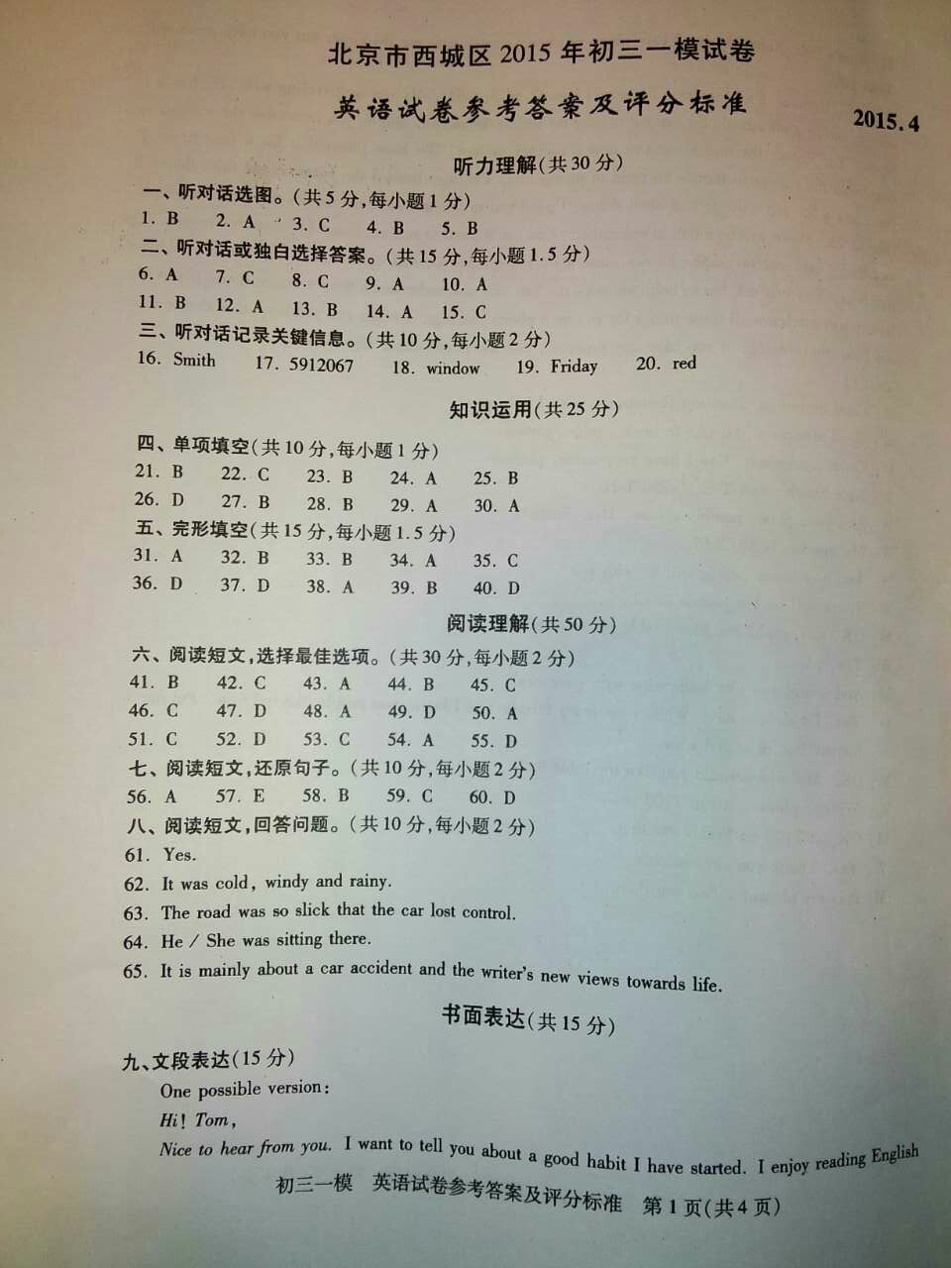

[来源:Zxxk.Com]

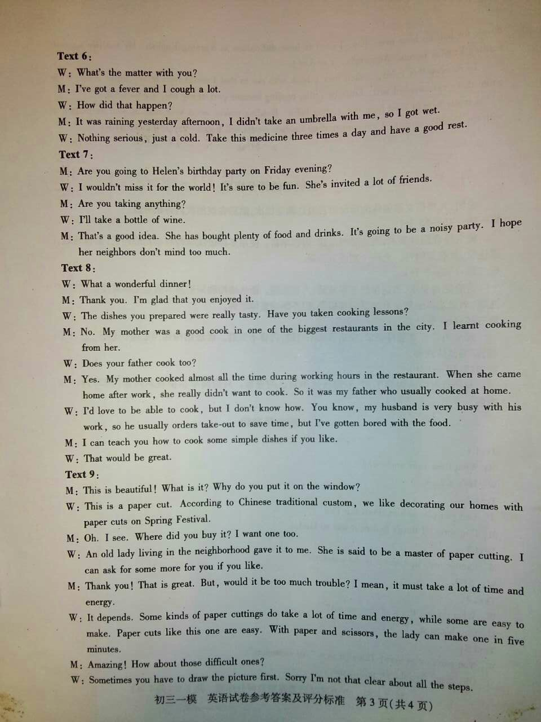
[来源:Z。xx。k.Com]

